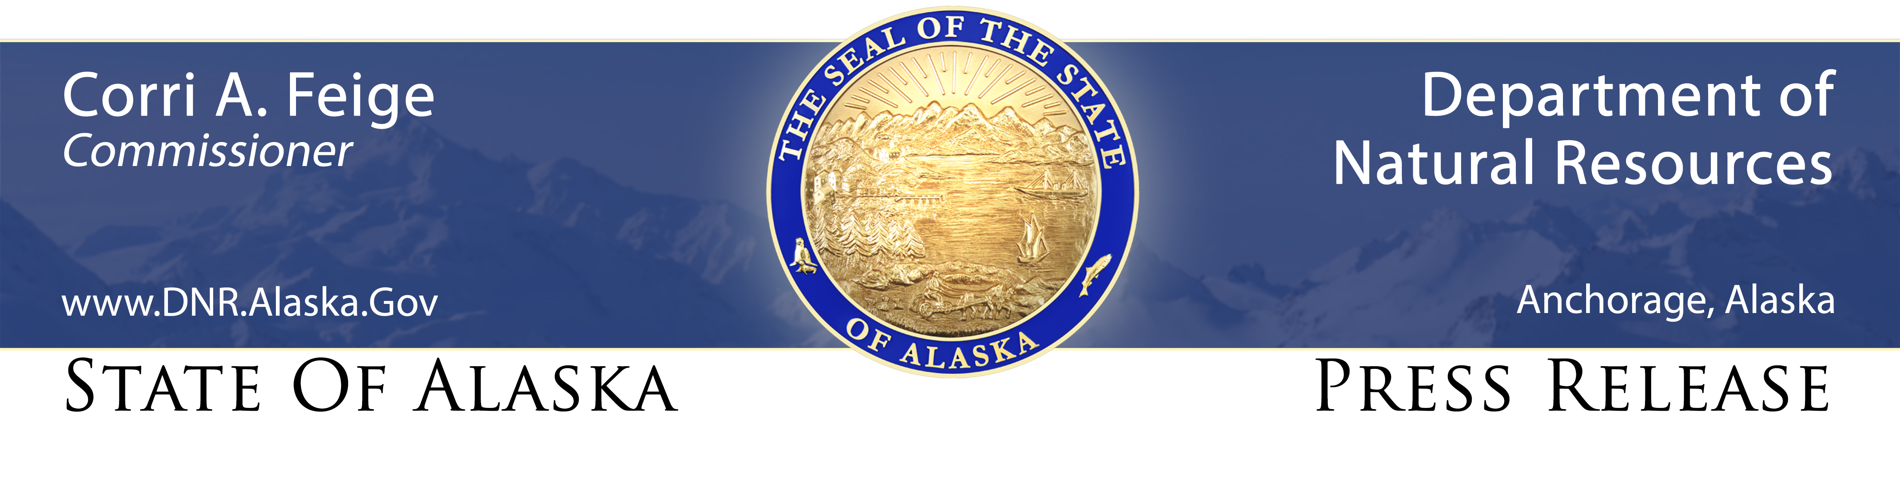
For Immediate Release: March 31, 2021

State forestry burn permits required starting April 1

(Fairbanks, AK) – Don’t let Mother Nature fool you with all that snow still on the ground, Alaska’s wildland fire season officially starts on Thursday, April 1.

While much of Alaska is still buried under a thick blanket of snow, state law requires those wanting to conduct any open burning on state, private and municipal lands from April 1 through August 31 to get burn permits from the state Division of Forestry. This includes burning brush piles, using burn barrels, agricultural burning and burning of maintained lawns.

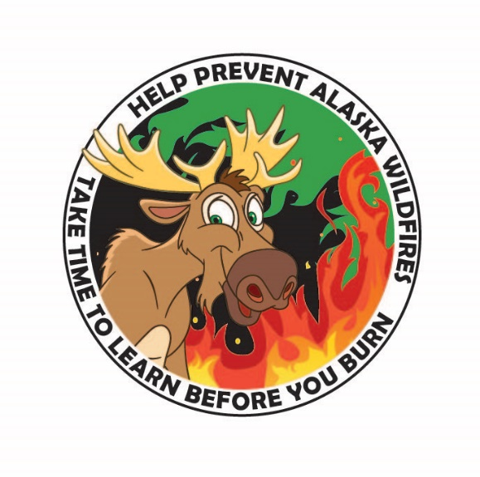
Burn permits are free and are available at local state forestry offices in Delta Junction, Fairbanks, Glennallen, Haines, Ketchikan, Palmer, Soldotna and Tok, as well as local fire departments in many of those same areas. Permits can also be printed online at https://dnr.alaska.gov/burn. Burn permits contain instructions for safe and legal burning.

“So far it looks like it may be a slow start to the fire season, but anyone who has lived in Alaska for any length of time knows conditions can and do change quickly,” said Norm McDonald, manager of the division’s Wildland Fire & Aviation Program. “Our firefighters are busy training so they’re prepared to protect Alaskans and their communities when that snow melts and fuels dry out.”

In the last 20 years, Alaska has seen a trend toward earlier, longer, and more intense fire seasons. Four of the 10 largest fire seasons on record in Alaska since 1939 have occurred since 2004.

In 2006, the Alaska Legislature advanced the start of the wildland fire season and burn permit requirement to April 1 from May 1 after back-to-back, record wildfire seasons in 2004-05. The change was made at the request of Alaska’s wildland fire management agencies, to allow earlier training for firefighters and to reduce human-caused fires before spring green-up.

“All the fires we respond to in April and most of May are started by some type of human activity because we don’t typically see lightning-caused fires until late May or early June,” McDonald said. “That means most early-season fires are preventable if people follow the safe burning guidelines on their burn permits.”

State forestry offices issue both small- and large-scale burn permits. A small-scale burn permit is required for anyone using a burn barrel, burning brush piles less than 10 feet in diameter and four feet high, or burning up to one acre of mowed grass less than four inches tall. Large-scale permits are required for burning that is larger or more complex than that allowed under a small-scale permit and require a site inspection by a division fire prevention officer.

Material that can be burned with a permit includes organic material such as leaves, brush, grass, lawn clippings, untreated wood, paper, or cardboard. It is illegal to burn substances such as plastics, garbage, rubber, Styrofoam, insulation, asbestos, painted or treated wood or anything else that produces black smoke. Those burning such materials can be cited and fined.

In addition to state permit requirements, local government regulations may prohibit open burning or use of burn barrels within some municipal and city boundaries. Residents should check with their local fire department to determine if burning is allowed in their area.

Burn permits are NOT required for camping, cooking or warming fires less than three feet in diameter with flame lengths less than two feet high. Violators of the permit requirements and safe burning instructions can be cited and held both criminally and civilly liable for the sometimes very substantial damage caused by an escaped fire.

The Division of Forestry encourages Alaskans to burn debris early in the season when the ground is still wet and fire danger is low, instead of waiting until later in the spring or summer when conditions are drier. Those with questions about burn permits and safe burning practices should contact their local forestry office.

CONTACT: Tim Mowry, 907-356-5512, tim.mowry@alaska.gov

###

